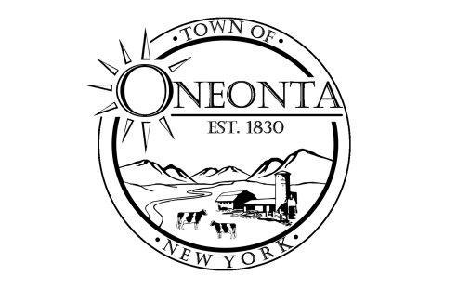**Town of Oneonta Planning Board**

**Meeting Agenda**

**August 5, 2024**

**Meeting called to order.**

**Pledge**

**PUBLIC HEARINGS:** none

**PUBLIC INFORMATIONAL MEETING:**

PB000618 Ford & Hill Holdings LLC/Joseph Vallette & Dan Hunter TMP#287.19-1-25.00; 128 Winney Hill Rd

Site Plan Review Application

**NEW APPLICATIONS: none**

**CONTINUING BUSINESS**: none

**DISCUSSIONS:**

**Minutes:**

Approval of 7/1/2024 Minutes

**Next Meeting:**

Meeting on 8/19/2024 @ 7:00PM

**ADJOURNMENT**