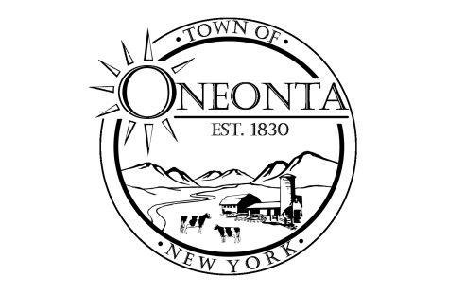**Town of Oneonta Planning Board**

**Meeting Agenda**

**July 1, 2024**

**Meeting called to order.**

**Pledge**

**PUBLIC HEARINGS:** none

**NEW APPLICATION:**

PB000618 Ford & Hill Holdings LLC/Joseph Vallette & Dan Hunter TMP#287.19-1-25.00; 128 Winney Hill Rd

Site Plan Review Application

**CONTINUING BUSINESS**: none

**DISCUSSIONS:**

**Minutes:**

Approval of 6/17/2024 Minutes

**Next Meeting:**

Meeting on 7/15/2024 @ 7:00PM

**ADJOURNMENT**