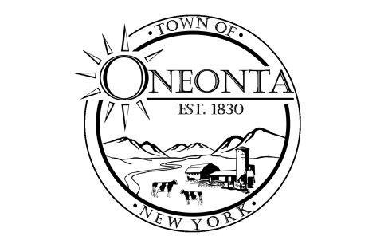
Town of Oneonta Planning Board
Meeting Agenda
June 17, 2024

Meeting called to order.

Pledge

PUBLIC HEARING:

PB000678 Davelyn Whyte-Jhonson TMP#299.07-2-15.00; 412 Chestnut St
Special Use Permit Application for short term rental

NEW APPLICATIONS: none

CONTINUING BUSINESS: none

DISCUSSIONS:

Minutes:
Approval of 6/3/2024 Minutes

Next Meeting:
Meeting on 7/1/2024 @ 7:00PM

ADJOURNMENT

