The regular meeting of the Oneonta Town Board was held on June 14, 2023 with the following members present:

Supervisor: Randal I. Mowers
Town Board Member: Brett Holleran
Town Board Member: Kim Fierke
Town Board Member: Skylar J. Thompson
Town Board Member: Patricia Riddell Kent
Town Clerk: Ryan F. Pereira
Town Attorney: Robert Panasci

Others present: James A. Hurtubise, Supt. of Highways; Michele Catan, County Rep.; Sharron Corrado; Gordon Huckins; Ellen Blaisdell; Patricia Jacob; Michael Schmitt; Denise Wist; Tom Armao; Richard Harlem; Tom Rowe; Jim Rowe; Ronald Bettiol; Andrea Lister; Steve Kent; Theresa Cyzeski.

Petitioners “Privilege of the floor”
PRK reintroduced Anthony Marris-Swann, the planner from MVEDD…Mohawk Valley Economic Development District. She said OCCA has transferred the contract for planning services directly over to MVEDD and MVEDD will honor it and provide their planning services at the same greatly discounted rate. PRK stated, “MVEDD has been instrumental in bringing millions of grant dollars into our region helping economic development.” Mr. Marris-Swann will return to the board at the next regular meeting.

RESOLUTION 2023-051 Motion made by Mowers, seconded by Thompson; ﻿set Public Hearing for the following regular Town Board meeting;
NOTICE OF PUBLIC HEARING
TOWN OF ONEONTA, NEW YORK

NOTICE IS HEREBY GIVEN that the Town Board of the Town of Oneonta, New York (the “Town”), will meet at the Town Hall, located at 3966 St Hwy 23, West Oneonta, New York, 13861 on the 12th day of July, 2023, at 7 P.M., for the purpose of conducting a public hearing upon a proposal to increase the amount expended to establish the Town of Oneonta Water District No. 5, at which time and place the Town will consider and hear all persons interested in the matter.

The purpose of the hearing is to solicit public input on a proposed resolution to increase the maximum amount expended for the construction, acquisition, operation, and maintenance of the Town of Oneonta Water District No. 5. The initial amount estimated to be expended at the time of the Order Establishing Water District No. 5 was $6,000,000, however, due to factors beyond the Town of Oneonta’s control, the maximum amount expended is proposed to increase to $7,000,000.

NOTICE OF PUBLIC HEARING
TOWN OF ONEONTA, NEW YORK

NOTICE IS HEREBY GIVEN that the Town Board of the Town of Oneonta, New York (the “Town”), will meet at the Town Hall, located at 3966 St Hwy 23, West Oneonta, New York, 13861 on the 12th day of July, 2023, at 7 P.M., for the purpose of conducting a public hearing upon a proposal to increase the amount expended to establish the Town of Oneonta Water District No. 6, at which time and place the Town will consider and hear all persons interested in the matter.

The purpose of the hearing is to solicit public input on a proposed resolution to increase the maximum amount expended for the construction, acquisition, operation, and maintenance of the Town of Oneonta Water District No. 6. The initial amount estimated to be expended at the time of the Order Establishing Water District No. 6 was $2,800,000, however, due to factors beyond the Town of Oneonta’s control, the maximum amount expended is proposed to increase to $3,200,000.

VOTE Aye (5) RM SJT MOTION CARRIED

RESOLUTION 2023-052 Motion made by Riddell Kent, seconded by Holleran;
Whereas the Board will vote to authorize Lamont Engineering to apply for applicable grants to fund much needed culvert replacements, standardization of water meters for Woodland Water District, the Plains, and a master water meter to Woodland; now, therefore be it
Resolved, that Lamont Engineering, as granted by the Town Board, will be authorized to apply for said grants, spending up to $500 for each grant application. Lamont would provide the engineering services for projects if awarded funding.

VOTE Aye (5) PRK BH MOTION CARRIED

RESOLUTION 2023-053 Motion made by Fierke, seconded by Riddell Kent;
Whereas the Town Board has reviewed, as per the Town of Oneonta purchasing guidelines, three quotes/bids from three different vendors; now, therefore be it
Resolved, the purchase of a new security system for the Town Hall from ADT is approved.

VOTE Aye (5) KF PRK MOTION CARRIED

RESOLUTION 2023-054 Motion made by Riddell Kent, seconded by Holleran;
Whereas the Town Board shall approve the contract as issued by Vacri Construction Corp., is modified;
Whereas as follows upon execution of this change order (Change Order No.:03);
Whereas Vacri will add a security fence around the wells and larger eyewash station per NYSDOH requirements;
Whereas now, therefore, be it resolved; the Town Board approves the change in contract price,
An increase of $13,737.09.

VOTE Aye (5) PRK BH MOTION CARRIED

RESOLUTION 2023-055 Motion made by Thompson, seconded by Riddell Kent;
Whereas now, therefore, be it resolved; the Town Board approves the rate changes for the Plains Water District.

VOTE Aye (5) SJT PRK MOTION CARRIED

Discussion to rezone the NY 205/23 corridor was tabled to July 12th meeting, Town Attorney Rob Panasci was to look into the zoning code.

RESOLUTION 2023-056 Motion made by Thompson, seconded by Holleran;
Whereas now, therefore, be it resolved; the Town Board approves of the appointment of Nicole Camarata to the position of co-budget officer.

VOTE Aye (5) SJT BH MOTION CARRIED

RESOLUTION 2023-057 Motion made by Thompson, seconded by Fierke;
Whereas now, therefore, be it resolved; the Town Board shall approve the new Travel Policy.

VOTE Aye (5) SJT KF MOTION CARRIED

RESOLUTION 2023-058 Motion made by Thompson, seconded by Fierke;
Whereas now, therefore, be it resolved; the Town Board shall approve the new Fixed Asset Policy.

VOTE Aye (5) SJT KF MOTION CARRIED

Privilege of the floor given to T Rowe; asked the Board to consider increasing fines to negligent landowners, to encourage clearing of unsightly: yard cars, waste, and debris, which may be considered a blight on the neighborhood therein. Supervisor Mowers said he will be looking onto the current fines assessed by the Codes Dept., and is open to having a dialog with the Codes Enforcer; noting, the fees had just been increased this year, and will look at the fines as well.

RESOLUTION 2023-059 Motion made by Thompson, seconded by Holleran;
Whereas now, therefore, be it resolved; the Town Board approves the payment of the bills.

VOTE Aye (5) SJT BH MOTION CARRIED

RESOLUTION 2023-060 Motion made by Riddell Kent, seconded by Fierke;
Whereas now, therefore, be it resolved; the Town Board shall accept the Minutes of the May 10th meeting.

VOTE Aye (5) PRK KF MOTION CARRIED

RESOLUTION 2023-061 Motion made by Thompson, seconded by Holleran;
Whereas now, therefore, be it resolved; the Town Board meeting be adjourned.

VOTE Aye (5) SJT BH MOTION CARRIED

Respectfully submitted,
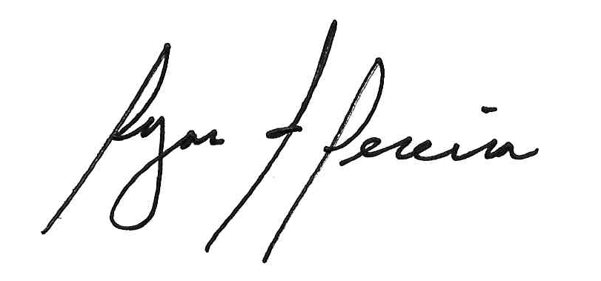
Ryan F. Pereira
Town Clerk

