The regular meeting of the Oneonta Town Board was held on December 14, 2022 @07:00PM, with the following members present:

Town Board Member: Kim Fierke (KF)
Town Board Member: Skylar J. Thompson (SJT)
Town Board Member: Patricia Riddell Kent (PRK)
Town Board Member: Brett Holleran (BH)
Supervisor: Randal I. Mowers (RM)
Town Clerk: Ryan F. Pereira (RFP) ABSENT
Town Attorney: Robert Panasci (RP) ABSENT

Others present: James A. Hurtubise, Superintendent of Highways; Michelle Catan, Otsego County Representative; Hunter Grace; David Kropp; Walter Schmitt; Michael Schmitt; Richard Harlem; Susan Morell; Emily Morell; David Morell; Denise Wist; Barbara Spataro; Jim Rowe; Steve Kent.

Petitioners: “Privilege of the floor.”

- Emily Morell sought approval from the Board for her Girl Scouts - Gold Award Project plans, to help improve the Town Pool in three phases:
Town Pool Improvement:
- I will create a larger shade area to help keep parents and people attending the
pool in the shade on hot days. There is already an existing pavilion there that
I plan to extend on both sides to create more seating.
- I will build and designate/place a handicap bench closer to the pool to create
easier access for people with special needs, and to designate a seating area as
handicap as well.
- I will improve the appearance of the area by painting the existing building as
well as repairing and painting the existing pavilion.

- Denise Wist, again spoke before the Board with ideas for a newly acquired property, 287.00-1-20.01, aka “The White Farm”, and petition for rezoning to open development on the land; as PDD, B1 or B2. She hopes to be able to create a wedding venue, housing, chalets, etc.

RESOLUTION 2022-101 Motion made by Thompson, seconded by Holleran to approve Ms. Morell’s Gold Award Project for improvements to the Town Pool.

VOTE – Ayes 5, Nays 0 SJT BH Motion Carried

RESOLUTION 2022-102 Motion made by Riddell Kent, seconded by Thompson to approve an application for funds from the NYS Bridge NY grant.

VOTE – Ayes 5, Nays 0 PRK SJT Motion Carried

RESOLUTION 2022-103 Motion made by Fierke, seconded by Riddell Kent to set a Public Hearing on the 11th of January for a Cannabis Retail Dispensary Law.

VOTE – Ayes 5, Nays 0 KF PRK Motion Carried

RESOLUTION 2022-104 Motion made by Riddell Kent, seconded by Thompson to certify delinquent Town Sewer and Water accounts for the year 2022, and submitting same to the Otsego County Treasurer for collection.

VOTE – Ayes 5, Nays 0 PRK SJT Motion Carried

RESOLUTION 2022-105 Motion made by Thompson, seconded by Fierke to establish a Highway Garage Reserve. This is subject to a referendum and notice will be put in the newspaper.

VOTE – Ayes 5, Nays 0 SJT KF Motion Carried

RESOLUTION 2022-106 Motion made by Fierke, seconded by Riddell Kent to establish a West Street Sewer Reserve. This is subject to a referendum and notice will be put in the newspaper.

VOTE – Ayes 5, Nays 0 KF PRK Motion Carried

RESOLUTION 2022-107 Motion made by Thompson, seconded by Fierke to establish Increasing Highway Equipment Reserve. This is subject to a referendum and notice will be put in the newspaper.

VOTE – Ayes 5, Nays 0 SJT KF Motion Carried

RESOLUTION 2022-108 Motion made by Holleran, seconded by Riddell Kent to establish Increasing Town Hall Reserve. This is subject to a referendum and notice will be put in the newspaper.

VOTE – Ayes 5, Nays 0 BH PRK Motion Carried

RESOLUTION 2022-109 Motion made by Thompson, seconded by Fierke to approve the transfer of budgeted funds to District Reserve Funds.

VOTE – Ayes 5, Nays 0 SJT KF Motion Carried

RESOLUTION 2022-110 Motion made by Thompson, seconded by Fierke to renew service agreements for Susquehanna SPCA and Super Heroes Humane Society.

VOTE – Ayes 5, Nays 0 SJT KF Motion Carried

RESOLUTION 2022-111 Motion made by Thompson, seconded by Fierke to approve Manufactured Home Community License Renewals for the following: Byam’s Trailer Court, Peaceful Flats, at this time. We are currently awaiting four complete applications, mailed out November 1st, 2022.

VOTE – Ayes 5, Nays 0 SJT KF Motion Carried

RESOLUTION 2022-112 Motion made by Riddell Kent, seconded by Fierke to approve and authorize, Skylar J. Thompson, and Ryan F. Pereira to attend the 2023 Association of Towns Training School and Annual Meeting in NYC (Feb.19-22).

VOTE – Ayes 5, Nays 0 PRK KF Motion Carried

RESOLUTION 2022-113 Motion made by Fierke, seconded by Mowers to designate Skylar J. Thompson as “Voting Delegate” in order to vote at the Business Session during 2023 The Association of Towns Training School and Annual Meeting in NYC.

VOTE – Ayes 5, Nays 0 KF RM Motion Carried

RESOLUTION 2022-114 Motion made by Riddell Kent, seconded by Fierke to pay the bills.

VOTE – Ayes 5, Nays 0 PRK KF Motion Carried

RESOLUTION 2022-115 Motion was made by Thompson, seconded by Riddell Kent to accept the November 9, 2022 minutes.

VOTE – Ayes 5, Nays 0 SJT PRK Motion Carried

RESOLUTION 2022-116 Motion was made by Thompson, seconded by Riddell Kent to adjourn.

VOTE – Ayes 5, Nays 0 SJT PRK Motion Carried

- Meeting adjourned 08:25pm.

Respectfully submitted,
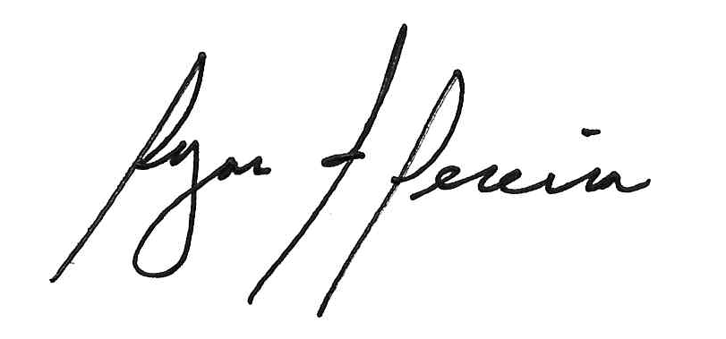

Ryan F. Pereira
Town Clerk

