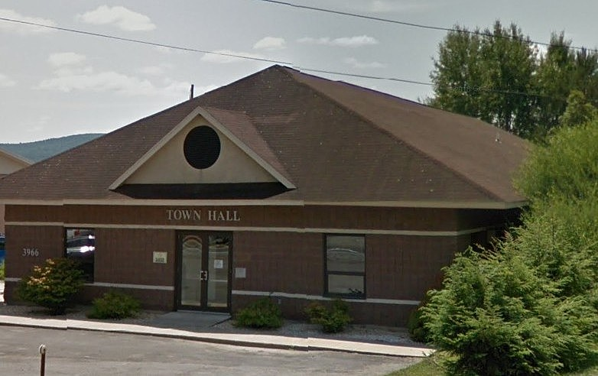
Town of Oneonta Greenhouse Gas Inventory
2021-2022

Town of Oneonta Greenhouse Gas Inventory Report for Government Operations
Background:
The Town of Oneonta adopted the Climate Smart Communities Pledge in April 2021 and subsequently formed a taskforce to complete actions to reach Bronze Certification within the program. Government Operations Greenhouse Gas Inventories are an important milestone for the community to establish a baseline understanding of energy usage and emissions by town operations and in formulating a Climate Action Plan for continued commitment to climate adaptation and mitigation projects.
This Greenhouse Gas Inventory for Government Operations catalogs the Town of Oneonta’s energy usage and emissions from town owned buildings, parks, outdoor lighting, sewer districts, and vehicle fleets for the years of 2021 and 2022. Using the recommendations from this report will assist the town in pursuing their goal of developing a Climate Action Plan.
Data and Methodology:
For the collection of this data the town partnered with Mohawk Valley Economic Development District Inc’s Sustainability Planner, Matthew Syke. This inventory was done using a GHG Inventory Spreadsheet developed by Climate Action Associates, LLC, which is compliant with the guidelines for GHG quantification and reporting set by the Local Government Operations Protocol (LGOP).
This inventory has been split into two separate scopes in accounting for Government Operations.
- Scope 1: Direct GHG emissions from government-owned vehicles and onsite fuel combustion (natural gas, propane, and fuel oil) for Administration buildings, and the Highway Garage.
- Scope 2: Indirect GHG emissions from purchased electricity.

Listed below are the Facility Groups, it should be noted that every account is provided by NYSEG. They are named in this inventory as they appear in the towns personal bookkeeping accounts.
Fortin Park
St Light #1
St Light #2
St Light #3
St Light #4
St Light #5
St Light (at large)
Old Highway Garage
WESD (West End Sewer District)
WSSD (West Street Sewer District)
SSD (Southside Sewer District)
WWD (Woodland Water District)
Town Hall
New Highway Garage
Town Pool

Key Findings:
The average Greenhouse Gas emissions for the years 2021 and 2022 from all municipal operations were 223.4 metric tons of CO2 (MTCO2e). The largest user of energy was the vehicle fleet at an average of 159.4 MTCO2e annually, or 71% of total emissions. The total average for administrative facilities is 44.4 MTCO2e, or 20% of total emissions.

Shown below, the emissions from diesel alone were more than both the towns electricity and natural gas emissions combined. With fuel sources broken-down diesel accounted for an average of 105.2 metric tons of CO2, while gasoline only 54.2.

The graph below shows the annual average for energy cost. Diesel accounts $32,703, this is second only to $37,701 for electricity, out of a total of $93,305 annually.

The highest user of energy for administrative facilities was the New Highway Garage with 32 metric tons on average. In 2022 the town converted this building to 30% geothermal. The next closest facility was the Town Hall with 12 metric tons annually. As seen the graph below it is worth noting the outlier of St Light (district) #1. This district has an annual GHG emission of 8 metric tons, while the other lighting districts produce at maximum 1 MTCO2e.
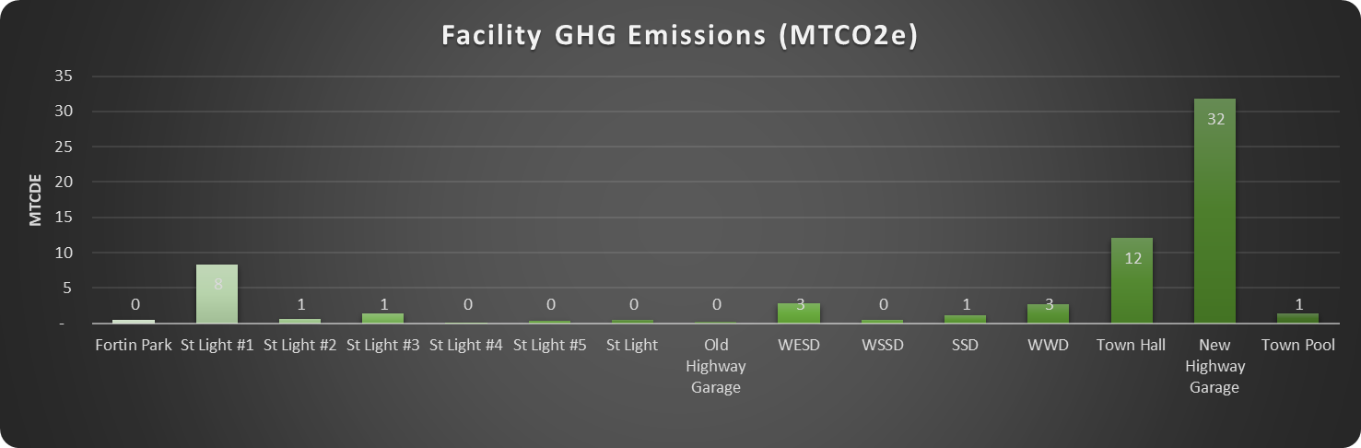

Greenhouse Gas Reduction Opportunities:
There are multiple opportunities for the Town of Oneonta to further reduce Greenhouse Gas emissions, however it should be noted that the town has already made steps to keep their operations relatively efficient. Their heavy-duty vehicles are all certified clean idle and the town has created a fleet inventory, but going forward it is recommended that they update and maintain this inventory to prioritize rightsizing and retiring of fleet vehicles. They have also discussed the option of switching some diesel vehicles to gasoline to cut back on energy cost and emission potential. The town also possesses a hybrid vehicle, but is considering the possibility of purchasing a full EV in the coming years for new staff. The DPW Supervisor has also expressed that he would like to purchase electric landscaping equipment for the whole department as soon as possible, which has the potential to offset some gasoline emissions.
Also, while their new highway garage was converted to 30% geothermal in 2022, the system had difficulties and needed to be serviced multiple times. In the coming years they will start to see the emission and cost reduction from this conversion more accurately. They are also looking to pursue a 100% conversion to geothermal for the new highway garage to further these savings/improvements.
In regards to lighting infrastructure, this inventory alerted them to the outlier of St Light #1 and its exceedingly large emissions. As part of the recommendations, they will be looking into this district to see the cause and if there are possible improvements that could be made to lower the output to a number that more closely resembles the rest of the lighting districts.

