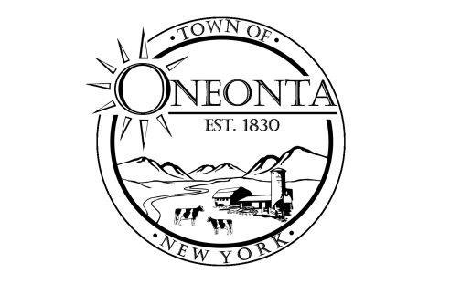
Town of Oneonta
Water and Sewer Department
James Hurtubise, Water & Sewer Operator
3966 St Hwy 23 · PO Box A West Oneonta, NY 13861
Ph: 607-432-2807 Office Email: hwysuper@townofoneonta.org

June 5, 2024

Dear Woodland Water residents,

As most of you are aware now, the Town of Oneonta Water system has expanded over the past year. We are proud to announce that after many years of hard work the Southside Water District is complete.
The system has been in operation since July of 2023 and supplies water to the Southside of Oneonta from Lowes to Home Depot, all of Southside Dr., Glen Dr, Bevins Dr. and part of Swart Hollow Rd. This project included two new wells in Fortin Park, new pump house, 500,000 gallon water tank, and over 8 miles of HDPE water line. The supply of water is very good and should provide reliable water to businesses and residents for many years.
What does this mean for the Woodland Water District Residents? As of September 2023 the Woodland Water District has been connected and using the water from the Southside Water wells. The Town will not be using the original Woodland water wells from here out. The wells and pump house have been reserved as back up only wells due to the slope failure at that location along the Charlotte Creek. It is not cost prohibitive to try to salvage that location due to future erosion and well failure.
What can you expect from this change? The new source of water from the wells at Fortin Park is of great supply and quality. This water is treated in a similar process as the Woodland Wells and is treated with Chlorine for disinfection and a phosphate solution for corrosion control. Most will not notice any change in water quality, taste, or pressure.
However, when switching over to these wells the flow of water has changed within the system. For some this will cause occasional brown or rusty color and some sediment. This is due to iron and mineral deposits on the pipes being disturbed by the change in water flow. In most cases the water clears up in a few minutes of running your tap. We have had reports of more persistent cases occur once a week or so.
The Town is aware of this and does have a plan to address this. The hope is that this sediment and scale can be flushed out with increase fire hydrant flushing. We will begin flushing all the hydrants in the district starting in June. We will be doing this once a month until the condition is resolved. We have also installed automatic flushing devices in appropriate locations to help remove this sediment and keep the system clean (Angel Dr. And Morningside Dr.). When the initial flushing starts some residents will notice the water maybe discolored or cloudy but this is temporary and will clear up with minutes of running the tap. It is recommended to never drink cloudy or discolored water and please run the tap until the water clears.

We apologize for any inconvenience but feel this issue will be resolved with these action. We continue to monitor the system daily and perform all the NYSDOH testing and sampling.

James Hurtubise
Town of Oneonta- Water and Sewer Operator
607-432-2093

