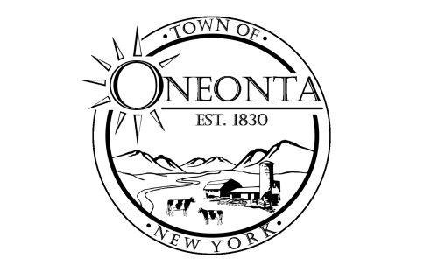
Town of Oneonta
Water and Sewer Department
James Hurtubise, Water & Sewer Operator
3966 St Hwy 23 · PO Box A West Oneonta, NY 13861
Ph: 607-432-2807 Office Email: hwysuper@townofoneonta.org

July 22, 2024

Dear Woodland Water and Southside Water Residents,

In response to water quality in the Woodland Water district which is now included in the Southside Water district. The Town has been aware of some water quality issues in the Woodland Water district following the connection to the new Southside Water district. We did anticipate some increased turbidity due to change in the flow on water in the distribution system and had hoped that district wide flushing earlier that fall would have reduced the impact.
Reports of discolored water from some residents on Angel Dr. since late fall of 2023 and on Morningside Dr. in the spring of 2024. This discolored water issue seemed to be an isolated issue and we immediately started to flush hydrants in the adjacent neighborhoods to remove some of the scale that had settled in the water mains. The scale is a collection of mostly iron and mineral deposits that have lined the inside of the water mains over past 40 years.
During this time, the Town has continued to monitor and test the water at the source and throughout the distribution system. We test monthly for Total Coliform and E.coli with no positive cases. The NYS Dept. Of Health has a long list of testing requirements that we test our system for annually. These test results continue to meet the regulation standards.
Most recently, we have completed lead and copper sampling in the district. We collected over 10 random samples from residents within the district to test lead and copper levels. Protocol requires these to be first draw samples from the resident’s cold water, typically in the morning. All ten samples properly collect met the regulation standards.
At the residents that have had persistent water quality issues we have done additional analysis of their worst samples. These are water samples that represent the worst condition of turbidity and sediment content. The samples did not test well and exceeded the maximum contaminant level fin multiple categories. But within minutes of running the tab the water clears and shows no evidence of contaminants. From the samples we have collected this is not representative of the systems water quality.
The response received from the Dept. of Health central office in regards to the results that exceeded the maximum contaminant level explains that the elevated level are most likely due to the particles in the water and not dissolved lead or copper. It is recommended to never drink cloudy or discolored water and please run the tab until the water clears.

The Town consulted with NYSDOH, engineers and other water professionals on this issue and has developed a plan to help mitigate. This summer we have started aggressively flushing the system to remove any scale and sediment on a monthly basis. We have also installed automatic flushing devices to flush the system as strategic location on a daily basis. The Town also plans to install permanent inline flushing taps in the water main at the most persistent areas of concern. When the initial flushing starts some residents will notice the water will discolored or cloudy but this is temporary and will clear up with minutes of running the tap. It is recommended to never drink cloudy or discolored water and please run the tab until the water clears.
The Town understands that water quality is of the most importance and wants to get any issues resolved a quickly as possible. We have made large invests into this system and will continue to insure its quality and safety for generation to come.

James Hurtubise
Town of Oneonta- Water and Sewer Operator
607-432-2093

