The regular meeting of the Oneonta Town Board was held on July 12, 2023, with the following members present:

Town Board Member: Brett Holleran
Town Board Member: Kim Fierke
Town Board Member: Skylar J. Thompson
Town Board Member: Patricia Riddell Kent
Supervisor: Randal I. Mowers
Town Clerk: Ryan F. Pereira
Town Attorney: Robert Panasci (phone-in)

Others present: James A. Hurtubise, Supt. of Highways; Michele Catan, County Rep.; Sharron Corrado; Gordon Huckins; Michael Schmitt; Denise Wist; Tom Armao; Richard Harlem; Tom Rowe; Jim Rowe; Ronald Bettiol; Andrea Lister; Steve Kent; Theresa Cyzeski.

Petitioners “Privilege of the floor”

Presentations

Jodie Serowski of Lamont Engineers was present to recap and answer any questions as the Southside Water Project comes to completion. The Board thanked Jodie and Michelle Catan for seeing the project through, and their efforts to help it come to fruition. Supervisor Mowers endorsed the following statement, “After 16 long years, the Town of Oneonta municipal services are celebrating a monumental achievement with the completion of the Southside Water project. This ambitious initiative aimed to revolutionize the water infrastructure of our town and enhance the quality of life for its residents and businesses. The project, which began in 2007, involved extensive planning and construction, including the installation of state-of-the-art water treatment plants, and the implementation of smart water management systems. The Southside Water project will ensure a more sustainable and reliable water supply, reducing water wastage and promoting conservation. It is expected to greatly improve water quality, address water scarcity issues, and provide a reliable source of clean water for generations to come. The successful completion of this project marks a significant milestone in the town's commitment to delivering essential services to the community.”

Anthony Marris-Swann, the planner from MVEDD…Mohawk Valley Economic Development District, returns to present to the Board regarding work towards a Comprehensive Plan update. Discussion from audience and Board members, centered on feasibility and experience to accomplish the task.

RESOLUTION 2023-062 (20:10) Motion made by Thompson, seconded by Riddell Kent;
Open Public Hearing for the purpose of public input on a proposed resolution to increase the maximum amount expended for the construction, acquisition, operation, and maintenance of the Town of Oneonta Water District No.5 & No.6.

The initial amount estimated to be expended at the time of the Order Establishing Water District No. 5 was $6,000,000, however, due to factors beyond the Town of Oneonta’s control, the maximum amount expended is proposed to increase to $7,000,000.

The initial amount estimated to be expended at the time of the Order Establishing Water District No. 6 was $2,800,000, however, due to factors beyond the Town of Oneonta’s control, the maximum amount expended is proposed to increase to $3,200,000.

VOTE Aye (5) RM SJT MOTION CARRIED

RESOLUTION 2023-063 (20:13) Motion made by Thompson, seconded by Riddell Kent;
Close Public Hearing for the purpose of public input on a proposed resolution to increase the maximum amount expended for the construction, acquisition, operation, and maintenance of the Town of Oneonta Water District No.5 & No.6.

VOTE Aye (5) RM SJT MOTION CARRIED
Closed without discussion.

Highway, Water and Sewer

Discussion continued about the Southside Water District, and the Department of Health’s stamp of approval with the disinfection process.

Superintendent Hurtubise let the Board know that work for the Blanchard Ave culvert was awarded a grant and will be fully funded for up to $1.91 million dollars.

RESOLUTION 2023-064 Motion made by Thompson, seconded by Holleran;
Whereas now, therefore, be it resolved; the Town Board approves the payment of the bills.

VOTE Aye (5) SJT BH MOTION CARRIED

RESOLUTION 2023-065 Motion made by Riddell Kent, seconded by Fierke;
Whereas now, therefore, be it resolved; the Town Board shall accept the Minutes of the June 14th meeting.

VOTE Aye (5) PRK KF MOTION CARRIED

RESOLUTION 2023-066 (21:05) Motion made by Thompson, seconded by Holleran;
Whereas now, therefore, be it resolved; the Town Board meeting be adjourned.

VOTE Aye (5) SJT BH MOTION CARRIED

Respectfully submitted,
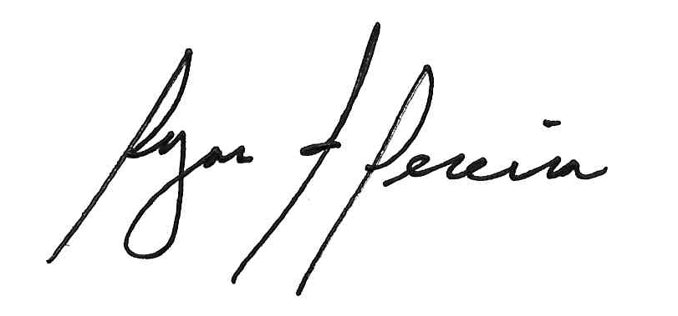
Ryan F. Pereira
Town Clerk

