The regular meeting of the Oneonta Town Board was held on February 08, 2023 @07:00PM, with the following members present:

Town Board Member: Patricia Riddell Kent (PRK)
Town Board Member: Brett Holleran (BH)
Town Board Member: Kim Fierke (KF)
Town Board Member: Skylar J. Thompson (SJT)
Supervisor: Randal I. Mowers (RM)
Town Clerk: Ryan F. Pereira (RFP) ABSENT
Town Attorney: Robert Panasci (RP) ABSENT
Attorney Pro Temp: Hyde Clark (HC)

Others present: James A. Hurtubise II, Superintendent of Highways; Jim Rowe; Dale Webster; Amy Wyant, OCCA, and Anthony Marris-Swann, MVED; Kyle Oliver; Chris Witzenburg; Christopher Rivera; Marjorie Pietraface; William Butler; Ron Bettiol; Cynthia L. Walton-Leavitt; Fran LaRocca; Bill Medlin; Jeanette Dutcher; Jaci Bettiol; Gabrielle Argo; Lisetta Coffin; Andrea Lister; Theresa Cyzeski; Patricia Jacob; Julie Grant; Bob Grant; Lynne Bolstad; Yoshiro Matsuo; Susan Ghaly; Jean M. Fleck; Richard Harlem; Steve Kent.

Petitioners: “Privilege of the floor.”

Christopher Witzenburg, Chief of Police, City of Oneonta; flanked by many concerned residents, presented remarks to address concerns over the closure of the FOX CARE Fitness Center, and citing overwhelmingly strong community support, hope for its future continuance. Supervisor Mowers followed the statements presented to the Board, and was able to relay that negotiations were underway, between Bassett Healthcare Network and the YMCA, to overtake daily operations, and hopefully continue to keep the fitness center open, serving the public good. The Board’s statement follows.

RESOLUTION 2023-038 Motion made by Riddell Kent, seconded by Fierke; ﻿
Whereas the Town Board of Oneonta recognizes Fox Care Fitness Center Facility as a vital component of the physical health and well-being of our community members;
Whereas Fox Care Fitness Center has become an integral part of the daily routine in the lives of many of the Town's retired population providing a substantial mobility, strength, and related physical and mental wellness benefit as well as social connectivity. Residents of all ages utilize this facility and value its services. It offers easy accessibility and convenient parking; and
Whereas the Town Board recognizes that the Fox Care Fitness Center services provided are valuable to the community in our upstate rural setting where the winter weather limits outdoor physical exercise; now, therefore, be it
Resolved, that the Oneonta Town Board;
strongly supports the Bassett Healthcare Network endeavoring to continue working with community partners to find a way to keep Fox Care Fitness Center facility open to the public.

VOTE Aye (5) PRK KF MOTION CARRIED

RESOLUTION 2023-039 Motion made by Holleran, seconded by Thompson;
Whereas the Board will authorize to sign the New York Empire State Development grant disbursement agreement; now, therefore be it
Resolved, that the Town Supervisor, as granted by the Town Board, will be authorized to sign said grant.
VOTE Aye (5) BH SJT MOTION CARRIED

RESOLUTION 2023-040 Motion made by Riddell Kent, seconded by Thompson;
Whereas the Town Board has reviewed the 2022 Budget Modifications; now, therefore be it
Resolved, the 2022 Budget Modifications are approved.
VOTE Aye (5) PRK SJT MOTION CARRIED

RESOLUTION 2023-041 Motion made by Riddell Kent, seconded by Mowers;
The Town Board shall approve of the Town Clerk’s attendance to the New York State Town Clerk’s Association Annual Conference and Training in Syracuse, April 24 & 25.
VOTE Aye (5) PRK RM MOTION CARRIED

RESOLUTION 2023-042 Motion made by Thompson, seconded by Holleran;
Whereas now, therefore, be it resolved; the Town Board approves payment of the bills.
VOTE Aye (5) SJT BH MOTION CARRIED

RESOLUTION 2023-043 Motion made by Fierke, seconded by Riddell Kent;
Whereas now, therefore, be it resolved; the Town Board shall accept the Minutes of the March 08th meeting.
VOTE Aye (5) KF PRK MOTION CARRIED

RESOLUTION 2023-044 Motion made by Riddell Kent, seconded by Thompson;
Whereas now, therefore, be it resolved; meeting adjourned @08:50PM.
VOTE Aye (5) PRK SJT MOTION CARRIED

Respectfully submitted,
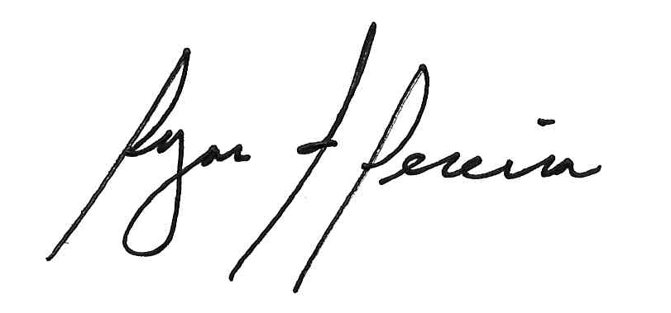
Ryan F. Pereira
Town Clerk

