The regular meeting of the Oneonta Town Board was held on
February 08th, 2023 @07:00PM, with the following members present:

Town Board Member: Brett Holleran (BH)
Town Board Member: Kim Fierke (KF)
Town Board Member: Skylar J. Thompson (SJT)
Town Board Member: Patricia Riddell Kent (PRK)
Supervisor: Randal I. Mowers (RM)
Town Clerk: Ryan F. Pereira (RFP)
Town Attorney: Robert Panasci (RP)

Others present: James A. Hurtubise II, Superintendent of Highways; Joe Denzak, Vortex International; Emily Morell; Susan Morell; David Morell; Walter P. Schmitt Jr.; Michael Schmitt; Jim Rowe; Dale Webster; Dale Webster; Theresa Desantis; Theresa Cyzeski; Victoria Spataro; Steve Kent.

Petitioners: “Privilege of the floor.”

- Emily Morell presented an update of her Gold Star Award project to the Board.
- Joe Denzak, with Vortex International presented to the Board ideas for adding a “Splash Pad” to enhance the Town Pool experience.

RESOLUTION 2023-038 Motion made by Riddell Kent, seconded by Fierke;
WHEREAS; PUBLIC HEARING OPEN, Local Law#1, “Cannabis Retail Dispensary Law of the Town of Oneonta.”
VOTE- Aye (5) PRK KF MOTION CARRIED

RESOLUTION 2023-039 Motion made by Thompson, seconded by Riddell Kent;

WHEREAS; PUBLIC HEARING CLOSED, Local Law#1, “Cannabis Retail Dispensary Law of the Town of Oneonta.”

VOTE- Aye (5) SJT PRK MOTION CARRIED

RESOLUTION 2023-040 Motion made by Riddell Kent, seconded by Fierke;

WHEREAS; approve the passage of Local Law#1 for the 2023 year, “Cannabis Retail Dispensary Law of the Town of Oneonta.”

VOTE- Aye (2) Nay(3) (BH, SJT, RM) PRK KF MOTION DENIED

RESOLUTION 2023-041 Motion made by Riddell Kent, seconded by Thompson;

WHEREAS; approve Surplus Equipment List:
2003 Interstate Trailer 20 Ton
Waste Oil Tank, Fuel Oil Tanks (2)
Hotsy Pressure Washer-As is, does not work properly
10' Fisher Plow Assembly, does not include frame
Shoulder Machine Attachment for Truck
Surplus Electronics from Town Hall

VOTE- Aye(5) PRK SJT MOTION CARRIED

RESOLUTION 2023-042 Motion made by Mowers, seconded by Thompson;

WHEREAS, The Board of the Town of Oneonta ("Town") has issued solicitations for sealed bids for the
construction of the Southside Water Project-Contract 5 -Service Meter Construction ("Project") as set
forth in the bid documents prepared by Lamont Engineers P.C.; and

WHEREAS, Lamont Engineers P.C. has reviewed the submitted bids for Contract No. 5 and has identified Oram Contracting, LLC, of Ghent, New York as the lowest responsive and responsible bidder and has recommended that the Town Board award Contract No. 5 in the amount of three hundred ninety five thousand five hundred thirty-seven and 00/100 Dollars ($395,537.00); and

WHEREAS, the Town Board may issue the Notice of Award for Contract No. 5, attached hereto as Exhibit A, upon review and approval of the low bid and Engineer's recommendation.

NOW, THEREFORE BE IT RESOLVED, that the Town Board does hereby award Contract No. 5 - Service Meter Construction to Oram Contracting, LLC, in the amount of three hundred ninety-five
thousand five hundred thirty-seven and 00/100 Dollars ($395,537.00), and be it further

RESOLVED, that the Town Board authorizes and directs the Supervisor to execute the related contract documents necessary to implement the intent of the foregoing resolutions in a form acceptable to Lamont Engineers P.C. and the Counsel for the Town as appropriate.

VOTE- Aye (5) SJT KF MOTION CARRIED

RESOLUTION 2023-043 Motion made by Riddell Kent, seconded by Fierke;

WHEREAS; approved seeking a timber sale proposal by Northeast Timber Services for soft wood thinning in Hemstreet Park.

VOTE- Aye (5) PRK KF MOTION CARRIED

RESOLUTION 2023-044 Motion made by Riddell Kent, seconded by Thompson;

WHEREAS; appointment of Andrea Lister to the Board of Assessment Review (BAR).

VOTE- Aye (5) PRK SJT MOTION CARRIED

RESOLUTION 2023-045 Motion made by Mowers, seconded by Thompson;

WHEREAS; Ryan Brooks has created an entity called Brooks' Roost, LLC; and

WHEREAS; the purpose of Brooks' Roost, LLC is to operate an on-site catering business on the campus of lands owned by Brooks' Bar-B-Q Realty, LLC., located at 5560 State Highway 7, Oneonta, New York and generally identified as tax map number 289.00-1-29.00; and

WHEREAS; Brooks' Roost, LLC has indicated its intention to file an application for a beer, wine and cider license with the New York State Liquor Authority; and

WHEREAS; among other things, any applicant for a license from the New York State Liquor Authority must serve the local municipality with a "Standardized NOTICE FORM for Providing 30-Day Advance Notice to a Local Municipality or Community Board," and

WHEREAS; the Town of Oneonta was served with the "Standardized NOTICE FORM for Providing 30-Day Advance Notice to a Local Municipality or Community Board," a copy of which is attached hereto and made a part hereof and marked Exhibit on March 2, 2023; and

WHEREAS; the Town of Oneonta may waive the 30-day advance notice requirement, as set forth in§ 110-b of the Alcohol Beverage Control Law,

NOW, THEREFORE, BE IT RESOLVED;

1. The Town of Oneonta hereby waives the 30-day advance notice requirement as set forth in§ 110-b of the Alcohol Beverage Control Law.
2. The Town of Oneonta has no objection if Brooks' Roost, LLC proceeds with submitting its application for a beer, wine and cider license to the New York State Liquor Authority, as noted in Exhibit as soon as conveniently possible.

VOTE- Aye (5) RM SJT MOTION CARRIED

RESOLUTION 2023-046 Motion made by Riddell Kent, seconded by Fierke;

WHEREAS; to accept the Minutes of the February 08th ,2023 meeting.

VOTE- Aye (5) PRK KF MOTION CARRIED

RESOLUTION 2023-047 Motion made by Thompson, seconded by Riddell Kent;

WHEREAS; adjournment for the March 08th ,2023 meeting;

NOW, THEREFORE, BE IT RESOLVED; meeting adjourned @09:00PM.

VOTE- Aye (5) SJT PRK MOTION CARRIED

Respectfully submitted,
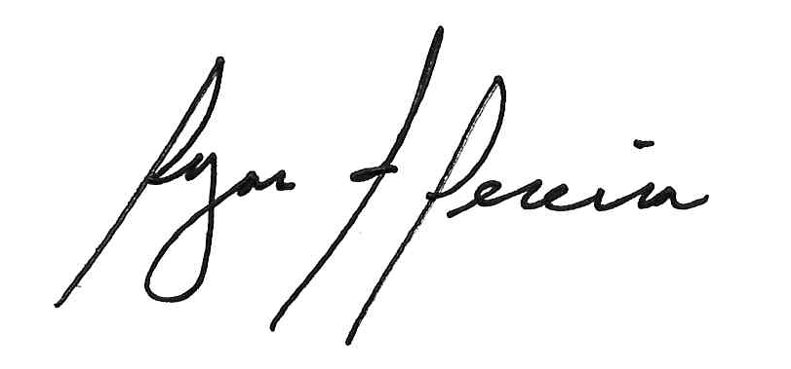
Ryan F. Pereira
Town Clerk

